Ruben Arutyunov

James Raboin

Iteration 3

**Game Dev Project Specification (Updated)**

**Story:** Occurs in the Star Wars universe. A murder has happened on the Bespin Station. You are a Jedi Knight who is in charge of finding the killer. There are 5 NPC’s that you will interact with. As you find clues and evidence, more parts of the story will “unlock”. Eventually, you will finish your investigation and approach the police chief and tell him who you think the killer is. After you make your selection, the game will tell you if you were right or wrong.

**Layout:**

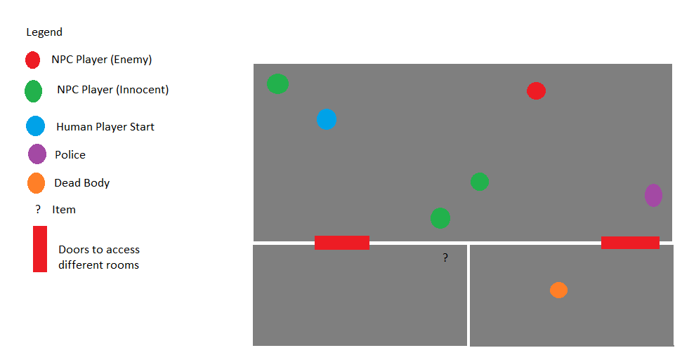

**Players**:

Human: (Jedi Investigator)

NPC’s: Vlad, Info Droid, Sasha, Garet, Cora, Trent, Police 1, Police 2, Yohan

**Human 1**: Jedi Investigator

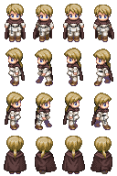

**NPC 4 (Innocent):** Garet (Bartender)

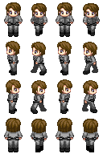

**NPC 5 (Innocent)**: Cora (Ambassador)

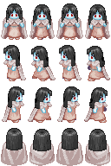

**NPC 6 (Guilty)** Trent (Sith):

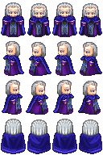

**NPC 7 (Police)**:

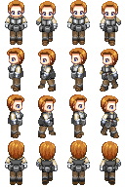

**Objects:** Collectible suspect items (Weapon)

**Physics:** Door enter/exit, character collision detection, character movement

**Events**: Door open/close, character/NPC interaction

**Audio**: Background music

**Rules/Objectives:** Talk with NPC’s, collect items to advance story and find murderer.

**Platform:** PC/Keyboard/Internet Browser

**Something that will be different:** Other rooms will be dark until entered. Only the room that human is in shall have light.

3)

Graphics:

Bitmaps with Images: These are the characters, and Items in the game.

Shapes with Graphics: Underneath each bitmap object, there is a shape object that we’ve used to move with the characters to detect collision, and trigger events to happen (Traverse rooms, Pick up object, etc.)

Animation: The main character is a sprite and walks (up, down, left, right) with the proper animation. The other characters and objects are stationary, but are also bitmap objects.

Input: Keyboard input must be provided for the main character to move.

Containers: Our characters are in containers with their shape objects to detect collision.

Sprites: All characters in this game are sprites.

Sprite animation: As stated above, the main character has been animated to walk.

One asset: Sound. Other than sound we have the background taken under no copyright infringement, and the characters are 8-bit characters free to use.

4)

The original game we envisioned is similar to the game we produced. It has the same story, most of the same characters, and the same objective. The subtle differences are a decrease in characters, and a decrease in objects to collect. The reason for this change is because of time, and the complexity of the game would have been quite extensive if we would have implemented all of the characters and objects in the game. This could have been avoided, given we had more time to work on the game.

5) **Credits:**

James: Object physics, event triggers, story, dialogue, sprites. 60%

Ruben: Sound, darkening of rooms when the player is not in the room, dialogue space and text placement, room and wall implementation, what and where item was to be placed, documentation, some character stories, some physics, some object creation. 40%?